Deadline 31 March 2024
£300+ offer for every home and business in Hockerton

Dear Hockerton resident,

Sustainable Hockerton is pleased to announce a new offer of £300+ to every home and business in the parish for energy saving and other measures promoting sustainability, funded by income from Sustainable Hockerton’s wind turbine and solar PV systems.

What can I claim for?

Broadly things that make living more sustainable and reduce carbon emissions. There is a comprehensive list below but if you have an idea that fits these aims and is not listed we may still be able to help please contact us to discuss.

How do I claim up to £300 or £500?

Each home and business in the Parish of Hockerton can claim up to £300 in this round towards installing the products and services named below and up to £500 for insulating house walls, lofts and floors above building regulations for new build or adding any insulation to current property including labour costs.

Applying is a simple three step process:

- Check Sustainable Hockerton funds what you want to buy, see list below.

- Submit the application form 1 and wait to receive the go-ahead.

- Assuming susses submit the claim form 2 stating how you would like to be paid with proof of purchase, e.g., copy of receipt.

Forms available on website or by contacting enquiries@sustainablehockerton.org or call 01636 816902 to find out more.

Ideas to keep heat in:
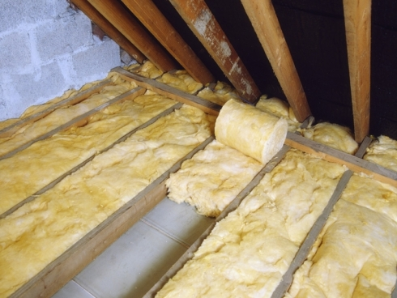
Draught proofing and lagging help keep homes cool and comfortable in hot weather whilst saving around £75 a year, and a hot water tank jacket could save £45 each year. Wall, floor and loft insulation and window treatments such as thermal-lined curtains or thermal blinds can keep heat in and noise out - useful for those residents living by the A617! Improving current window glazing will also reduce noise and improve heat retention. Less intrusive options include letterbox draught excluding, chimney balloons and loft hatch draught excluding.

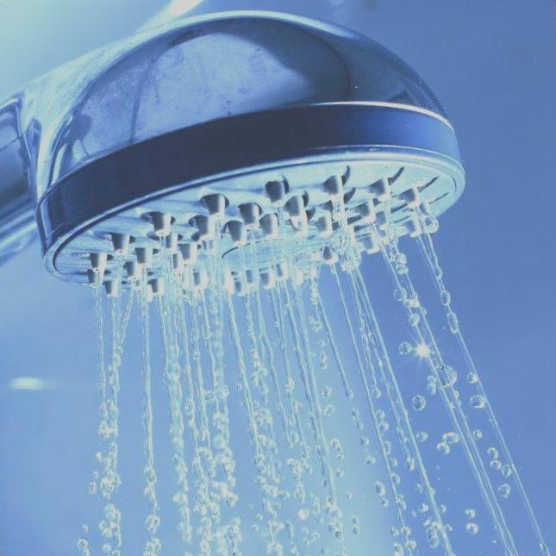
Water saving

If you want to manage your energy and water bills, then conservation makes good sense. How about water efficient taps? A water efficient shower head costs around £27 and can save a family of four around £75 a year on water heating, and another £90 if they have a water meter. Or how about a water butt to save water and money in the garden?

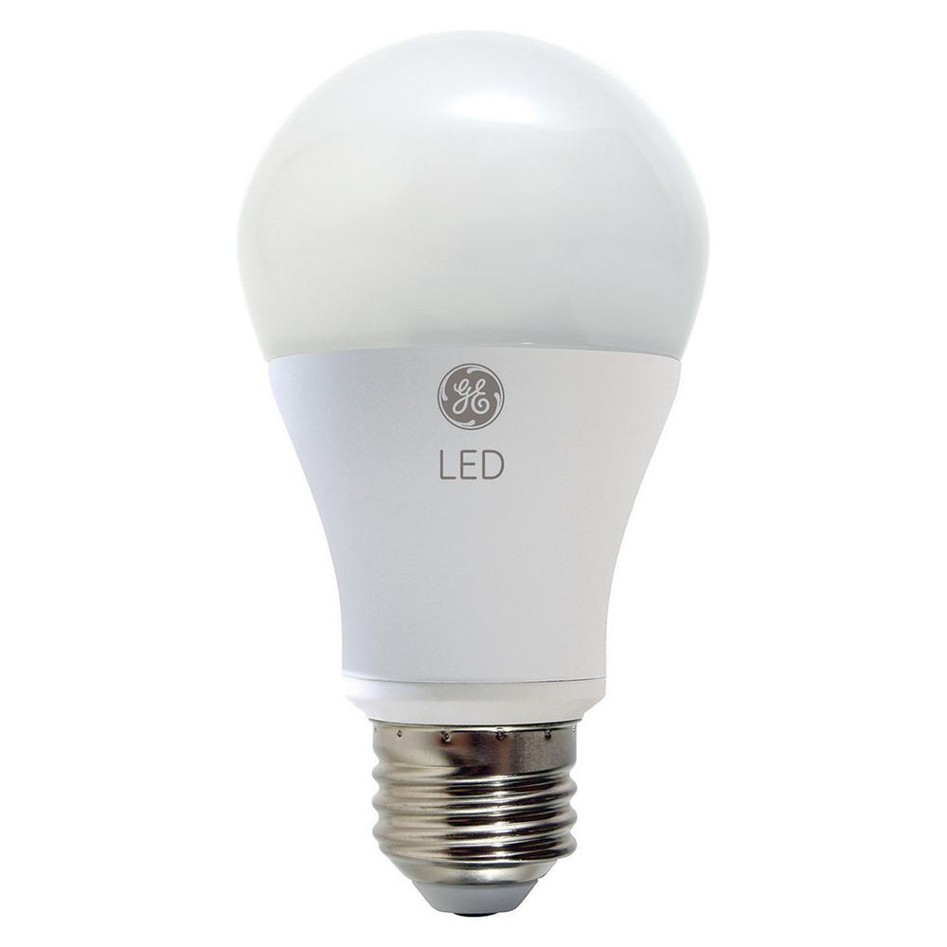
See the light!

Energy efficient bulbs such as LED lights last as much as 50 times as long as incandescent bulbs, saving money on energy use and new bulbs, but this is only a sustainable option if the light quality is good enough. Look for a warm white or soft white bulb or a Colour Rendering Index (CRI) of at least 80. Get more advice on the Energy Saving Trust website and look for the EST Recommended label.

In the garden

If you want to grow your own food and reduce carbon footprint by reducing food miles and packaging, previous Hockerton residents have got fruit trees and bushes, providing great yearly fruit. To help grow you could also get hand gardening tools and compost boxes. Or if gardening isn’t your thing, what about an organic veg box delivered to you?

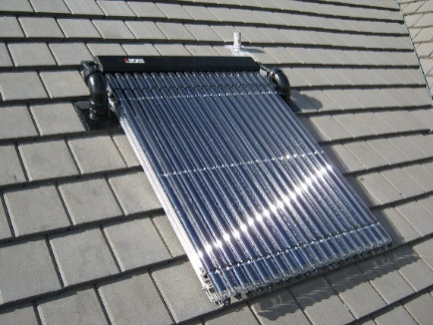
Renewable Energy

Cut your energy bills and install photovoltaic panels or solar thermal panels. Change your boiler to use a renewable fuel.

After recently moving we were completely oblivious of the poor level of insulation in our large loft. Over the winter the house was freezing cold and the frequent supplies of oil to keep it warm were extremely costly. At the time Sustainable Hockerton was offering support with environmental initiatives and they certainly came to our rescue in part funding loft insulation. Since then we have undertaken other projects such as insulated linings for curtains to conserve heat and we are gradually replacing bulbs with more eco options.

I have now re-bulbed the whole house. Has certainly made a difference – my 32 day electricity consumption for Nov-Dec period appears to be 25% below annual average for a month which given it is a winter month is fantastic!! Thanks to SHOCK for encouraging me to make the change.

What is included?
- Fruit bushes and trees, vegetable plants
- Gardening / vegetable growing equipment, hand tools, spade, fork, raised bed edging
- Organic seeds and compost
- Organic vegetable boxes
- Composting boxes
- Water butts
- Draught proofing including Chimney balloons
- Letter box draught excluding
- Washing lines and rotary driers
- Hot water tank insulation including labour
- Loft insulation including labour
- Loft hatch draught excluder including labour
- House cavity wall insulation including labour
- House underfloor insulation including labour
- Insulated lining for blinds and curtains including labour
- Radiator reflector
- Improved window glazing above current installation.
- Energy use monitor
- Photovoltaic panels making electricity
- Solar thermal panels making hot water
- Heat pumps
- Boiler replacement that uses a renewable fuel
- Water efficient shower heads and flow restrictors
- Radiator Thermostats can be electronic
- Energy advice/ assessor, Energy saving advice
- Pressure cooker or Wonder bag/ hay box
- Ventilation heat exchanger
- LED light bulbs
- Insulated house door above your current standard door
- Electric car and car charging point
- Battery storage island & connected to the mains power
- Bicycles electric or human powered
- Bicycle repairs
- Heat camera survey of property (Available from HHP)
- Battery electric lawn mower and strimmer
- Books; There is No Planet B by Mike Berners Lee and other environmental books
- Parts to repair items listed here
- Second-hand purchases of items listed

What is not included:
- Household appliances including; cooker or hob, dishwasher, washing machines, tumble dryer.
- Fossil fuelled lawn mowers or other garden machinery.
- Second-hand or new purchases within households or businesses.
- Repairs to fossil fuelled vehicles.

The small print (Terms and Conditions)

Please complete application form and wait for approval before purchasing improvements. Open to both owner-occupied and rented homes (subject to relevant permissions) and to business premises in the Parish of Hockerton. Limited to one offer per household or business, per year. Advice on measures is available from the Energy Saving Trust and Waterwise. Participants will need to provide a comment on their use of the offer to help inspire others and/or inform future projects. Such comments may be used on our website or other media. Personal details will be protected. Trustmark advises on reputable tradesmen. Please support local businesses such as local builders and handymen, and suppliers such as the Handicentre or Christys Interiors where possible. And please get in touch if there is a measure you want to install but is not listed - particularly if it is one recommended by the Energy Saving Trust and Waterwise - or if you have an idea that you want to take forward that will support the economic, social and environmental wellbeing of the village but is in need of financial assistance. Limited funds available. The directors of SHL keep the right to refuse an application and may have to withdraw the offer at any time.

If you complete the forms, you are giving permission for SHL and Hockerton Housing Project (HHP) (Who manage SHL activities) to communicate with you about the offer and to let you know about future offers and promotions etc. You can remove yourself from this by emailing or contacting us in other ways. We will not sell your details to third parties. If you want to see the full details of our privacy policy, please see our web site.

The large print
If you require this leaflet in large print, please call us on 01636 816902 or contact us in other ways.

